**Course outline**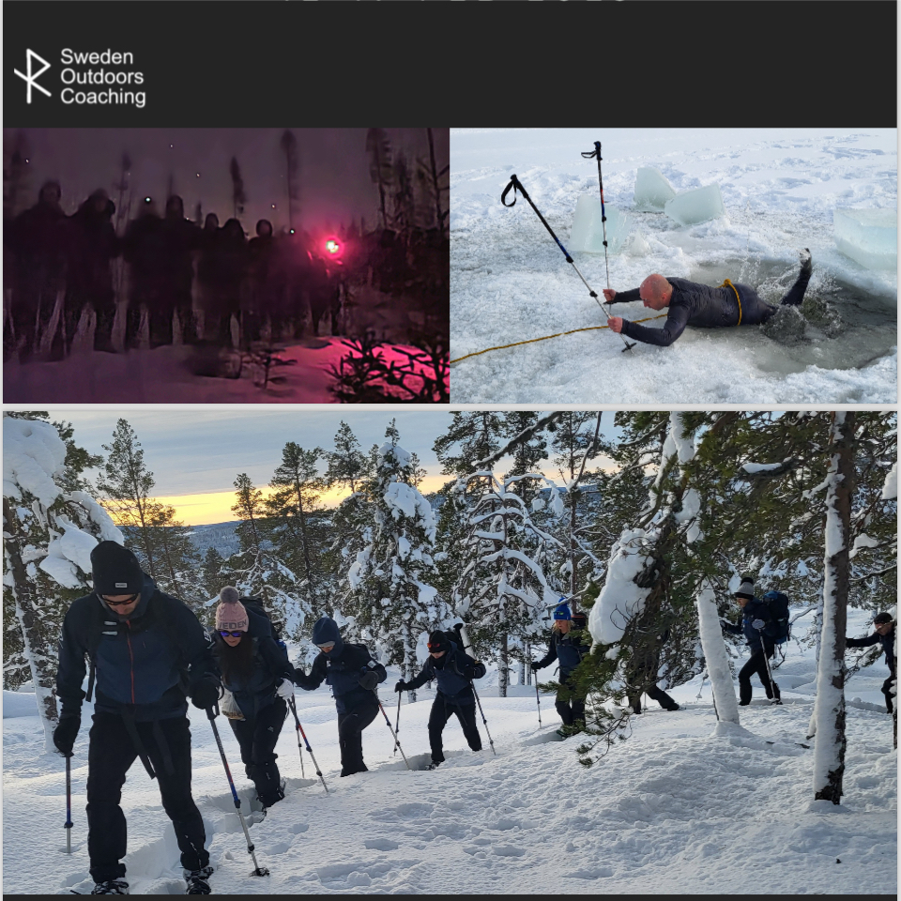



'SURTHRIVING'

NORTHERN SWEDEN

February 2026

**With Wye knot community & Sweden outdoor coaching!**

**Dates**: 12-19 Feb 2025

**Costs**: £1400/pp all included apart from flights

**Location**: Northern Sweden

**Adventure**: An introduction to winter bushcraft and Surviving in

‘Sub-Arctic conditions.

**Numbers**: Max 8

**Ability**: Novice through to proficient

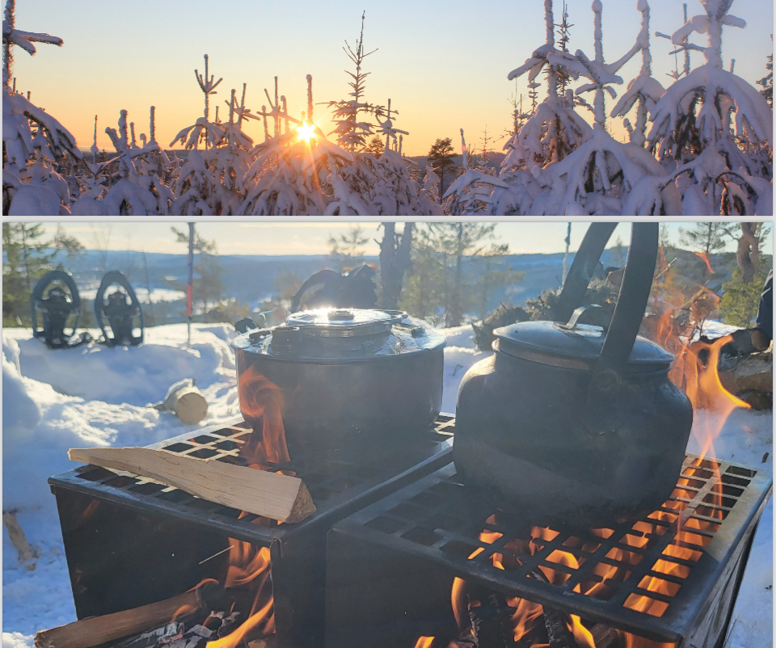

Join us for an unforgettable Winter Bushcraft Course in Northern Sweden, where you'll not only master essential survival skills in the heart of the sub-Arctic but also deepen your team's connection and unlock its full potential.

Set against the stunning backdrop of snow-covered forests and frozen lakes, this hands-on course challenges you to collaborate and overcome obstacles as you learn to thrive in extreme winter conditions.

You'll work together to master fire-starting techniques, build shelters, navigate the snowy landscape, and find and prepare food in the wild.

Guided by experienced instructors, you'll develop crucial teamwork skills, including communication, problem-solving, trust-building, and leadership. Discover the power of collective effort as you navigate the wilderness, understand natural navigation, and stay safe in the cold.

Whether you're a seasoned outdoor enthusiast or a complete beginner, this course will push your team's limits and build confidence in your collective abilities.

With the potential of the mesmerising Northern Lights above and a true sense of adventure, this experience is perfect for teams looking to strengthen bonds, enhance communication, and unlock their full potential through a shared challenge. Prepare for an exhilarating adventure and leave with a deeper appreciation for Sweden's winter beauty and your team's incredible capabilities!

DAILY ROUTINE

Each day starts with a hearty breakfast to fuel the day's activities, which will of course be governed by a thorough risk

assessment of the weather and the group's welfare. Lunch is enjoyed in the great outdoors, sometimes in a snow-walled wind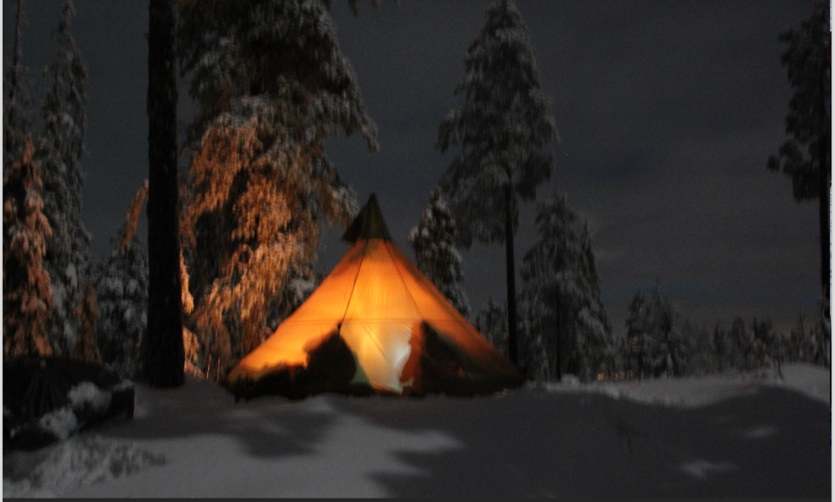 shelter, and

sometimes in the glorious winter sun!

NATURE AND LOCAL ENVIRONMENT

Previously on this course, we have seen deer, reindeer, moose, ptarmigan, capercaillie and even signs of wolverine! There is also a very good chance that we will experience the northern lights in a uniquely 'light pollution-free zone'

- a real 'once in a lifetime

experience and good for the soul!

FINAL CHALLENGE

To test your ‘Surthriving’

the ability we plan to spend 2 nights on a mini-expedition

in the forest putting into practice all your new knowledge & skills.

**Course content**

Aim:

An opportunity to learn and apply skills to be able to thrive in a winter environment

Objectives:

During the course, the following elements will be covered:

1. Winter Hazards and how to risk assess.

2. Bushcraft skills for the winter environment.

3. Winter surviving and ‘thriving’ techniques.

4. Navigation and route planning.

5. Snowshoeing and use of Pulk.

6. Winter camping.

7. Ice-breaking drills.

8. Introduction to Nordic Skiing.

Pre-Expedition Training:

You will have regular contact with Rose Sales & Lou Lupo (Course Leader) via online meetings in the months leading up

to the trip, with advice on training to get you in shape, top tips for preparing your equipment and food,

and also how to make life easier for yourself whilst on course.

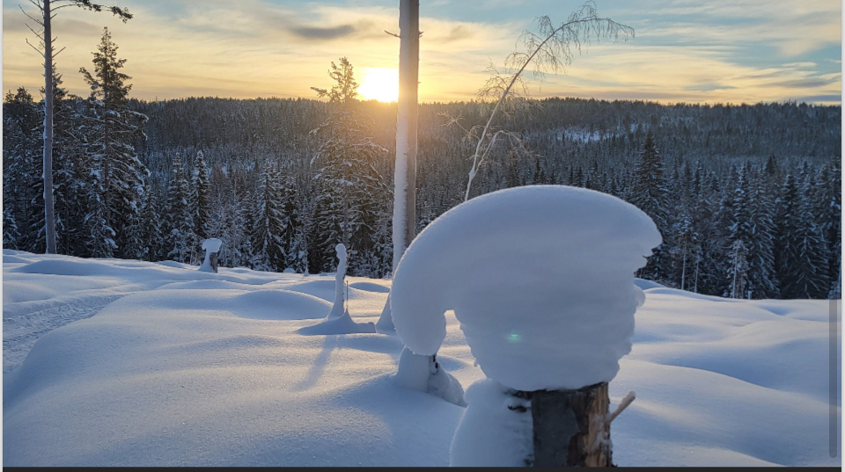

E X P E D I T I O N L O G I S T I C S

Travel- Flights:

You are responsible for booking your RTN flights to Sweden su. However, we will advise on suitable airports and travel solutions,

dependant on your wishes, with the option of potentially extending your stay in Sweden after the expedition!

Travel In Country:

We will book all 'in-country travel' which is included in the expedition price from Sundsvall /Train Station.

Accommodation:

Accommodation from 12-19 Feb 2025 is included in the expedition price.

Equipment Hire:

All expedition equipment will be provided by Sweden Outdoors Coaching.

Personal Equipment:

We will advise on suitable equipment in the months leading up to the expedition with a PDF Equipment doc and regular posts (often

through a Social Media Group (or email)). Essentially, you will need a good set of clothes and equipment which are suitable for

Scottish Winter + a 4-season sleeping (can be hired)

Food:

All food will be provided and we are very familiar with catering for various dietary requirements.

Costs Included: Not Included:

Travel from the airport /Train Stn Return Flights to Sweden

All accommodation 12-19 Feb 2025 Any other in-country travel

All Bushcraft and Group Safety Equipment Personal clothing and equipment (PDF Doc)

All Coaching/Guiding and Risk Management Lunch Food and beverages

Evening Meals, lunches and Breakfast Travel Insurance

**About Sweden's outdoor coaching**

Sweden Outdoors Coaching offers personalized outdoor training, expeditions, and consulting. We specialize in s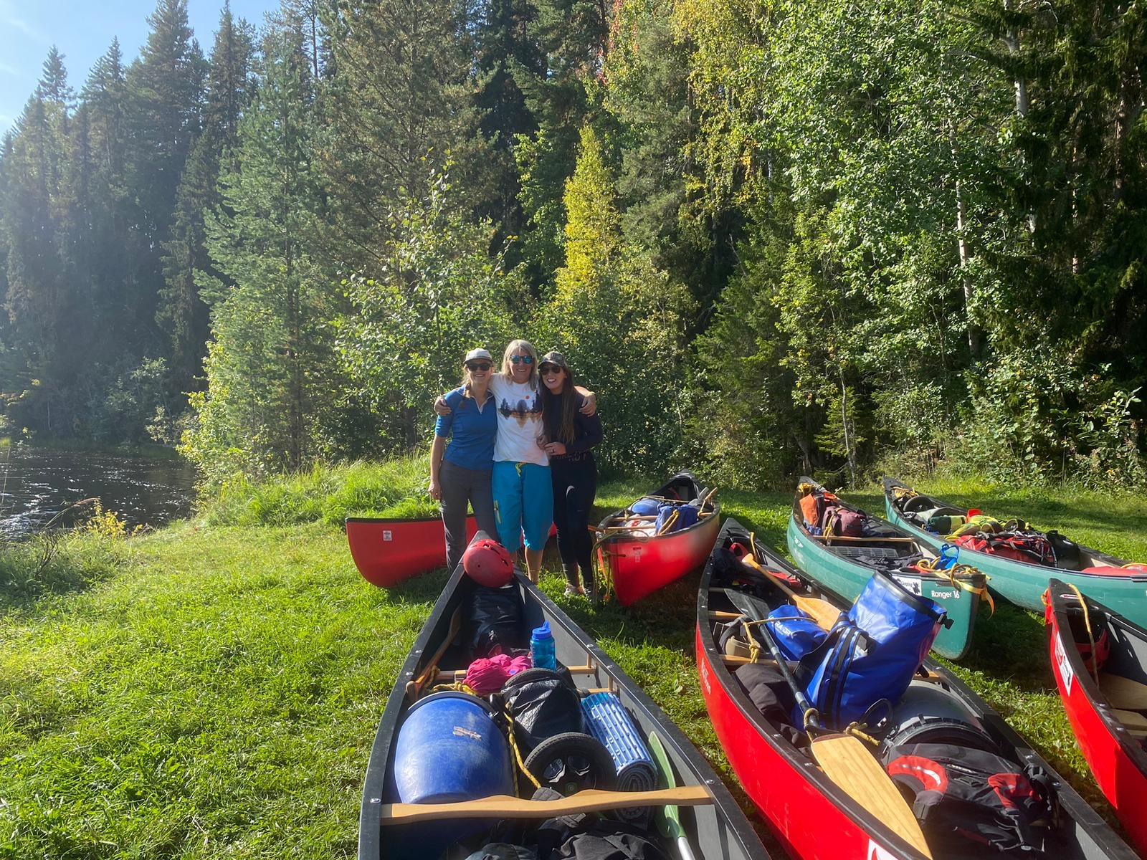kill development, risk management, and environmental awareness. Our programs cater to all experience levels, from beginner to expert. Join us for unforgettable adventures in stunning locations worldwide.

Visit Sweden Outdoors Coaching for more information.

**About your leader**

Louise Lupo (Lou)

A dynamic leader and experienced mentor, Lou brings over two decades of outdoor expertise to our Sweden Outdoor Women

‘Survthriving

’

Week. Lou retired from the Royal Air Force (RAF) in 2020 having served 24 years as a Physical Training Instructor-

specialising in Adventurous Training (AT). Throughout her career, Lou has coached and developed numerous members of all 3 services

in a variety of AT disciplines including Summer/Winter Mountaineering, Rock/Ice Climbing, MtnBiking, Open Canoeing, River/Surf

Kayaking, PaddleBoarding and Skiing. Lou has served in Outdoor Centres in Scotland, North/ South Wales and Bavaria culminating in

her becoming the first female Chief Instructor of the largest Outdoor Centre within the RAF at the time.

During her time in the RAF Lou has had the privilege of leading and assisting on many expeditions Worldwide, summiting a live volcano

in Chile to Ice Climbing in Canada to name a few. Lou has always had a passion for wilderness survival since building dens and

making mud pies as a child (you have to be a child of the 70s to fully appreciate that!). Qualified as a Unit Survival Instructor she

assisted in the delivery of survival training packages to RAF pilots and aircrew, also under the RAF Eagles scheme has led many

Wilderness Open Canoeing Trips in Sweden.

**Rose Sales (assistant coach** )

Rose Sales is the founder of Wye Knot Community. She is a passionate advocate for connecting generations and empowering

communities through nature. She has a wealth of experience in creating inclusive experiences for people of all ages, having worked as

an activities director, led movement therapy for seniors, and pioneered intergenerational groups. Some of her proudest achievements

include founding Playing Together, Herefordshire

’

s first intergenerational playgroup, co-creating WyldWood, a newspaper bridging

generations during the pandemic, and being part of the River Carnival. Her love for the outdoors led her to become a Paddle Boarding

and Forest School leader, and she now guides women in wilderness adventures. Rose Sales holds a Diploma in Health and Social Care for

Social Care &amp; Children, an NVQ 2 in Activity Leadership, a Diploma in Leisure Management, a Level 3 in Outdoor First

Aid, Paediatric First Aid, Mental Health First Aid Training, a Level 3 Forest School Practitioner, and a Level 3 British Canoeing Coach and

Paddle Board Coach. She is currently training towards her mountain leadership qualification.

**Anja Larsson Clifford (assistant coach** )

Anja is a newly graduated Nature Guide and Sea kayak instructor based in Sundsvall Sweden. Her interest in the outdoors came from

**Contact**

**Rosemary@wyeknotcommunity.com**

a need for a healthier and happier life; now she is always excited to share experiences and beautiful environments with anyone able to

get out! At the moment Anja is employed as an indoor climbing instructor and working towards starting an outdoor adventure and

retreat guiding service. Meeting new people and spending time together outside is the most natural yet precious thing for Anja. She

can't wait to share a cold winter week with you!